**CISC2005 Lab 02 - Week 02**

**INSTRUCTIONS FOR CISC2005 Suggested Exercise 02**

**Eclipse IDE for C/C++ Developers - Setup with "cygwin" GNU C/C++ Tool Chain**

* Download and Install Java into your computer, by following the instructions at the link below:
  + [How do I manually download and install Java for my Windows computer?](https://java.com/en/download/help/windows_manual_download.xml)
  + [Java SE Runtime Environment 8 Downloads](https://www.oracle.com/technetwork/java/javase/downloads/jre8-downloads-2133155.html)
  + Capture at least 2 screen shots to show the successful installation of the above Java SE Runtime Environment in your computer.
* Download and Install "cygwin" into your computer, if you have not done so, by following the instructions at [CISC2005 Lab 1](https://ummoodle.um.edu.mo/course/view.php?id=157683#section-5):
  + [How do I download and install Cygwin?](http://www.mcclean-cooper.com/valentino/cygwin_install/)
  + [How do I select packages to install in Cygwin?](https://ptolemy.berkeley.edu/ptolemyII/ptII2.0/cygwin.htm)
    - binutils
    - make
    - gcc-core
    - gdb 8.3.1 (Note the version!!!)
  + [How do I open Cygwin terminal in Windows?](https://smallbusiness.chron.com/run-cygwin-programs-cmdexe-50317.html)
  + Capture at least 2 screen shots to show the successful installation of the cygwin Environment in your computer.
* Download and Install "Eclipse IDE for C/C++ Developers"
  + Click the link: [Download Page of Eclipse Foundation](https://www.eclipse.org/downloads/packages/)
  + Download [Eclipse IDE 2020-12 Installer](https://www.eclipse.org/downloads/packages/release/2022-12/r/eclipse-ide-cc-developers) (you need to select a site from which to download)
  + Capture at least 2 screen shots to show the successful installation of the above Eclipse IDE in your computer.
* Create a workspace for your projects when starting Eclipse IDE for C/C++ Developers as follows:
  + From the Window menu, select **File->New** and go to **C/C++ Project**.

* + Choose option **C Managed Build** and click **Next**.

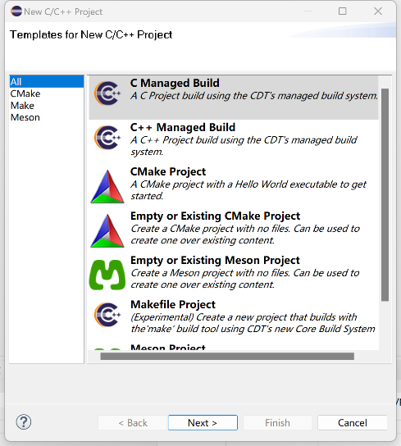

* + Name the project as "CISC2005-SugEx02" in your computer such that you have a path similar to the one below:
    - d:\cisc2005-2021\ CISC2005-SugEx02
  + Create a **Hello World ANSI C Project** and choose **Cygwin GCC** as Toolchains.

* + Capture at least 2 screen shots of your Eclipse running with the path of your workspace shown, and

**Project Setup under Eclipse IDE**

1. Select your Eclipse workspace at CISC2005-SugEx02
2. Create C program files named "CISC2005-SugEx02.c".

1. Try to build the project. Click the **Build** button in the upper left corner of the window.

1. Test-run the CISC2005-SugEx02 C programs in the Eclipse project spaces. Select the generated executable, right click, and select **Run as->****Local C/C++ Application**.

1. Debug “CISC2005-SugEx02.c”. Double-click the location of line 15 of the file to set a breakpoint. Then right-click and select **Debug as->Local C/C++ Application**.
2. You may need to locate the source file when debugging for the first time.

1. Capture at least 2 screen shots to show your test-run results and the Eclipse WS folder containing your project spaces.

**Suggested Exercise 02 - Submission**

1. Create a folder named "CISC2005WS-SugEx02-your student ID".
2. Put all screen shots into the folder "CISC2005WS-SugEx02-your student ID", including those under the following:
   * My Screen Shots of Successful Installation of Java SE Runtime Environment 8 (or 11 or 15)
   * My Screen Shots of Successful Installation of cygwin (Linux) Environment
   * My Screen Shots of Successful Installation of Eclipse IDE for C/C++ Developers
   * My Screen Shots of Successful Test-Run under respective project spaces in Eclipse IDE: "CISC2005-SugEx02".
3. Zip the folder "CISC2005WS-SugEx02-your student ID", and name it " CISC2005WS-SugEx02-your student ID.zip" (note the ".zip" extension is not part of the name). Please do not use ".rar" format when zipping - use only ".zip" format.
4. Submit your zipped file " CISC2005WS-SugEx02-your student ID.zip" at [CISC2005 Submission Link for Suggested Exercise 02 - Due on 2023FEB09 11:59 pm](https://ummoodle.um.edu.mo/mod/assign/view.php?id=2960025" \t "_blank)

 This should facilitate the grading work of our TA.

**Suggested Exercise 01 - References**

* [CISC2005 ANSI C Tutorials 01 - 07](https://ummoodle.um.edu.mo/mod/folder/view.php?id=2050026)
* [Griffiths, David, & Griffiths, Dawn (2012). Head First C - A Brain-Friendly Guide. O'Reilly.](https://ummoodle.um.edu.mo/brokenfile.php#/6163/user/draft/420240351/head-first-c-o-reilly-david-grifffiths-dawn-griffiths.pdf)
* [Learn C Programming](http://learn.onlinegdb.com/learn_c_programming)
* You might want to use the Atom text editor for composing your programs. It works the same on Windows, Macintosh, and Linux. You can download and install it from: <https://atom.io/>